Mission Control has lost its SQL Connection
Sometimes the Mission Control Application of the Landing Pad server might lose its connection to its SQL Server. This event will cause the Web Portal Sales Information not to be up to date, and the customer, might be calling us for this reason.
Although this event is rare, it would require a considerable amount of time to troubleshoot, without the proper documented steps.
The following is a description of how you might troubleshoot a situation such as the above described.
Customer Calls stating that none of its stores have sales for yesterday, or today.
- The First Step to troubleshoot an even such as this will be to connect to the Landing Pad server and try to run the “Mission Control Application”. The “Mission Control Application” has a section named “SQL Server Name”. This section must have a valid SQL server Name, and it should be accessible in order for the information of the stores to make it to the Web Portal. This is a picture of the Mission Control displaying a “Blank” SQL Server Name, and therefore causing the issue.
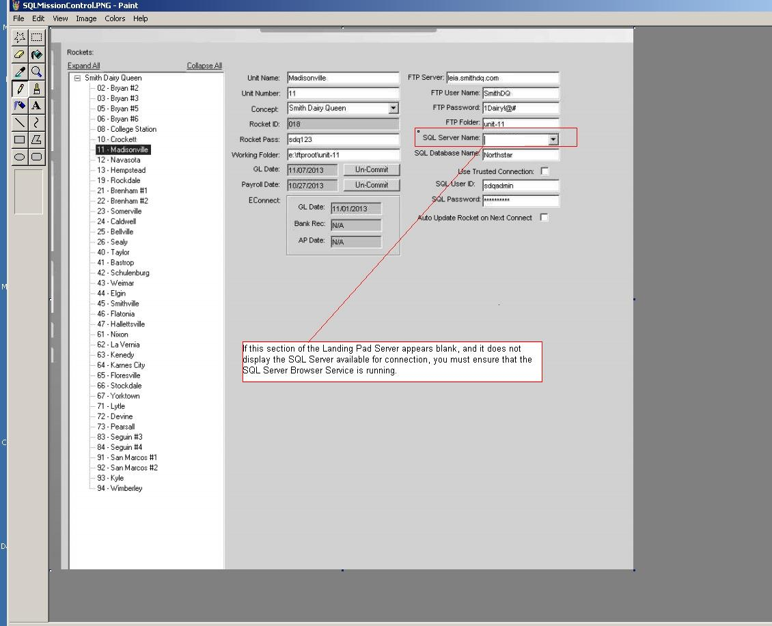

To find the SQL Server Name, you can use the entry in a file called Web.config. This file usually resides in the Server that is hosting the NorthStar Portal and most of the times it has the following path:
C:\Program Files\NorthStar\Enterprise Portal\NSPortal
Here is a picture displaying the location of the Web.config file.

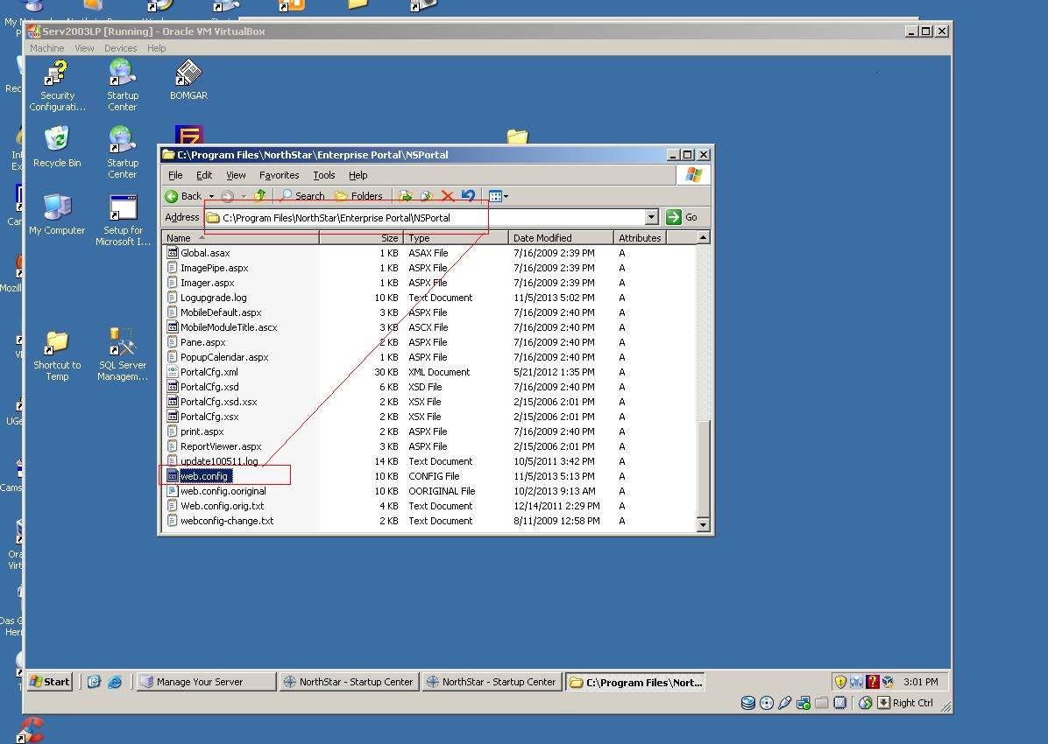

Using Notepad try opening the web.config file, and notice the entries which mention the SQL Server Name for the NorthStar Database as displayed in this picture:

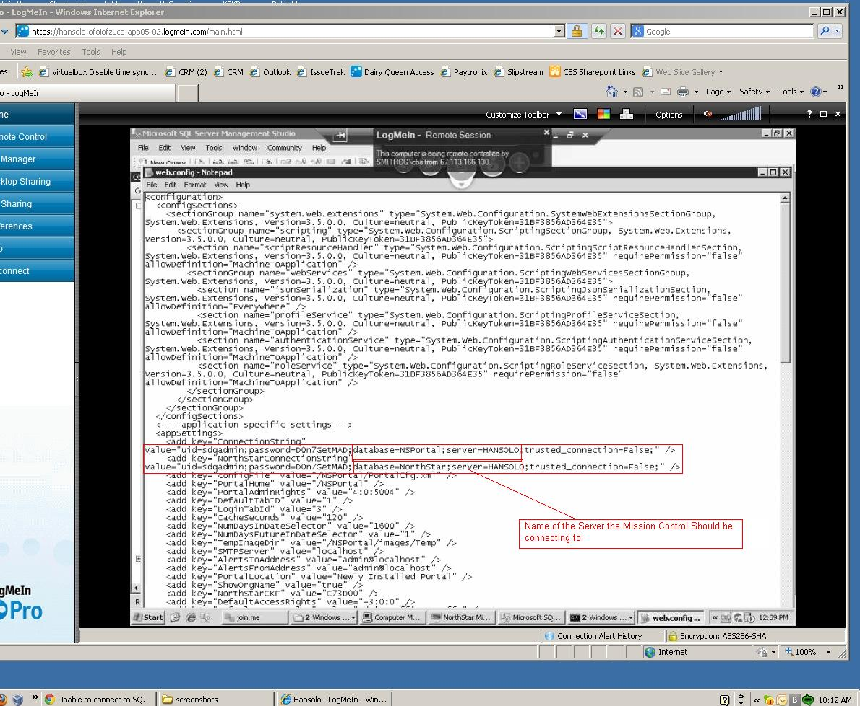

Once you have found the SQL server the NortStar Database resides in, (in this case the server is HANSOLO). You will have to connect to the Computer hosting the HANSOLO SQL Server, and in its services you MUST ensure the SQL Server Browser service is running. Here is a picture:

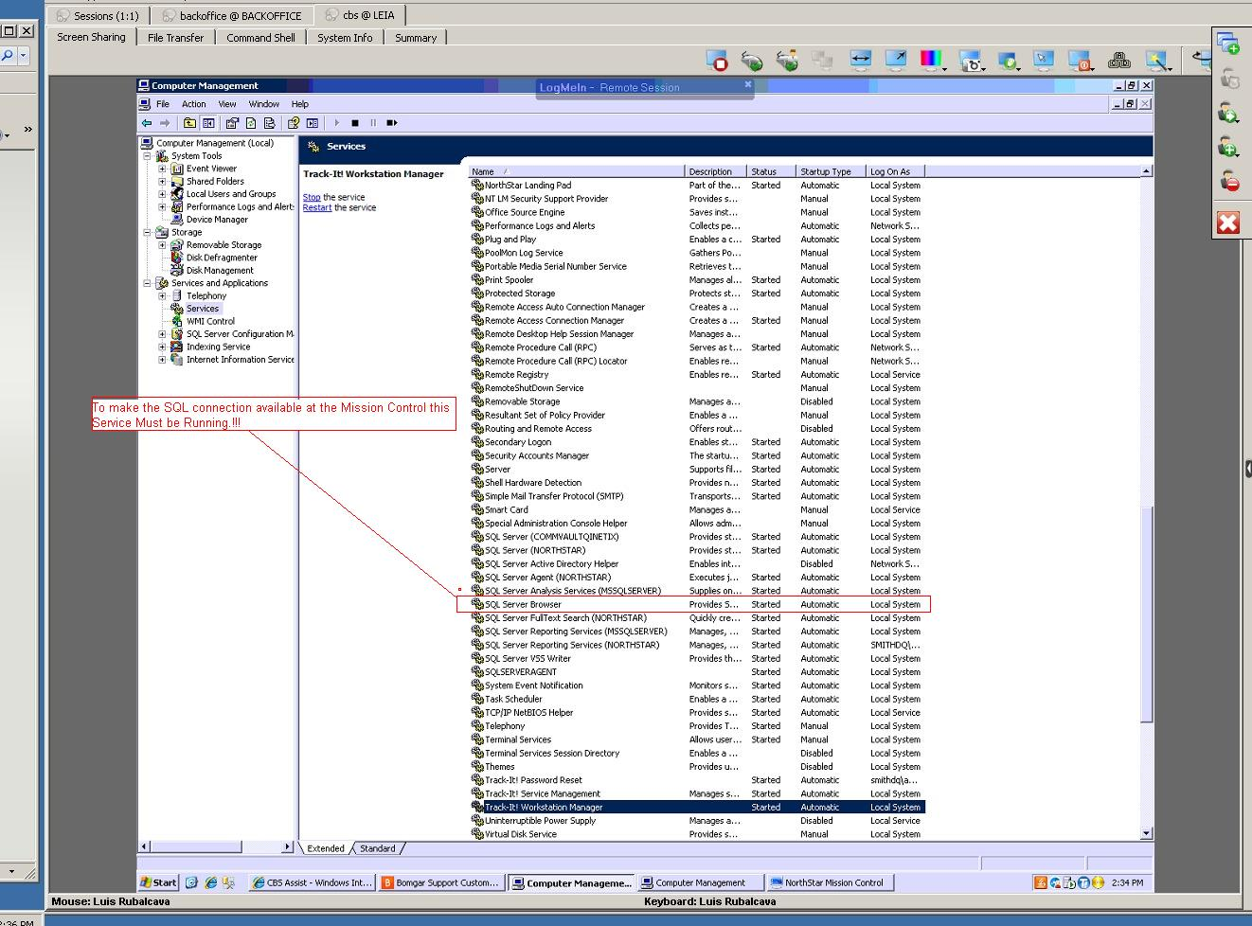
The SQL Server Browser is the service that makes the server available for connections, and it makes the name of it available in the different SQL Connections.
Once the SQL Server Browser is running, you will need to go back to the “Mission Control” Application, and in its “SQL Server Name” try to use the drop down arrow, and select the Server described in the Web.config file. Do not forget to click on “update” once you have made the Server Selection, so the connection to the SQL Server can be confirmed.
If the Connection is successful, the Mission Control will start working again.

